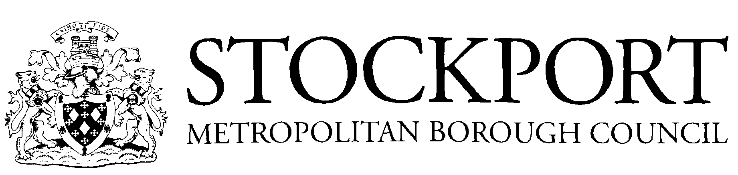

School Year 2025/2026

Autumn Term 2025
- Term Begins – Monday 1st September 2025
- Half-Term Holiday - Monday 27th October 2025 to Friday 31st October 2025 (inclusive)
- Term Ends – Friday 19th December 2025
- Christmas Holiday 2025/2026 – Friday 19th December 2025 to Friday 2nd January 2026 (inclusive)
Spring Term 2026
- Term Begins – Monday 5th January 2026
- Half-Term Holiday - Monday 16th February 2026 to Friday 20th February 2026 (inclusive)
- Term Ends - Friday 27th March 2026
- Easter Holiday 2026 – Monday 30th March 2026 to Friday 10th April 2026 (inclusive)
Summer Term 2026
- Term Begins – Monday 13th April 2026
- Half-Term Holiday – Monday 25th May 2026 to Friday 5th June 2026 (inclusive)
- Term Ends – Monday 27th July 2026
- Summer Holiday 2026 - Begins Tuesday 28th July 2026

Public Holidays
- Good Friday - Friday 3rd April 2026
- Easter Monday - Monday 6th April 2026
- May Day – Monday 4th May 2026
- Spring Bank Holiday – Monday 25th May 2026

Inset Days

TBC

