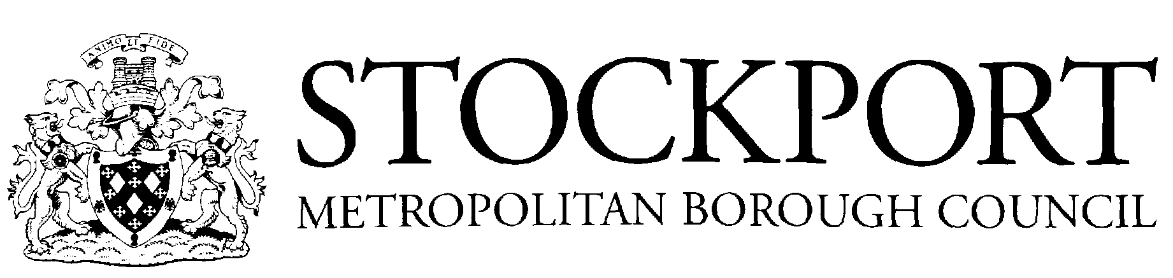

School Year 2024/2025

Autumn Term 2024
- Term Begins – Monday 2nd September 2024
- Half-Term Holiday - Monday 21st October 2024 to Friday 25th October 2024 (inclusive)
- Term Ends – Thursday 19th December 2024
- Christmas Holiday 2024/2025 – Friday 20th December 2024 to Wednesday 1st January 2025 (inclusive)
Spring Term 2025
- Term Begins – Thursday 2nd January 2025
- Half-Term Holiday - Monday 17th February 2025 to Friday 21st February 2025 (inclusive)
- Term Ends - Friday 11th April 2025
- Easter Holiday 2025 – Monday 14th April 2025 to Friday 25th April 2025 (inclusive)
Summer Term 2025
- Term Begins – Monday 28th April 2025
- Half-Term Holiday – Monday 26th May 2025 to Friday 6th June 2025 (inclusive)
- Term Ends – Friday 25th July 2025
- Summer Holiday 2025 - Begins Monday 28th July 2025

Public Holidays
- Good Friday - Friday 18th April 2025
- Easter Monday - Monday 21st April 2025
- May Day – Monday 5th May 2025
- Spring Bank Holiday – Monday 26th May 2024

Inset Days

Monday 2nd September 2024
Thursday 2nd January 2025
Friday 3rd January 2025
Monday 24th February 2025
Thursday 1st May 2025

