
Dyslexia Guidance for families

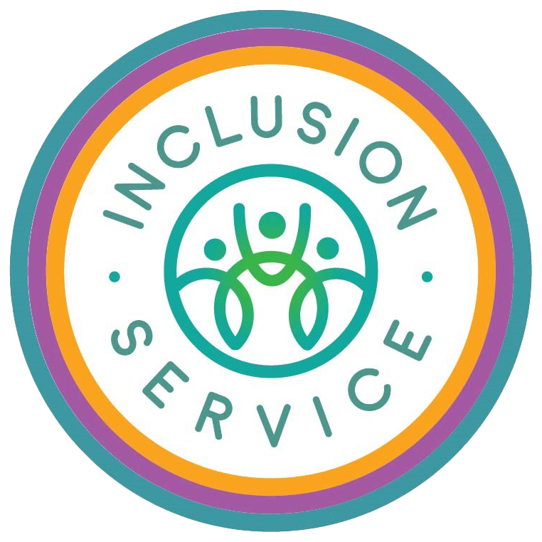


Introduction

This document is adapted from Stockport’s ‘Dyslexia Guidance for Schools’ (written by Stockport Learning Support Service, Educational Psychology Service & Stockport SEND Strategic Lead).

What is dyslexia?

There is no one agreed definition of dyslexia, and despite the considerable level of research, the numbers of pupils and causes of dyslexia vary widely.
In the interest of improving outcomes for children and young people with specific literacy difficulties, and to provide clarity for parents and professionals, Stockport has adopted the following definition;
The Rose Report, published in June 2009, endorsed by the Government states;
‘’ Dyslexia is a learning difficulty that primarily affects the skills involved in accurate and fluent word reading and spelling.’’
The definition acknowledges that;
- Characteristic features of dyslexia are difficulties in phonological awareness, memory and processing speed.

- Dyslexia occurs across a range of intellectual abilities.

- Complexities may be seen in aspects of language, co-ordination, mental calculation, concentration and personal organisation, but these are not, by themselves markers of dyslexia.

- A good indication of the severity of dyslexic difficulties can be gained by looking at how the child/young person responds or has responded to well-founded interventions and supporting strategies.

Neurodiversity and dyslexia
The British Dyslexia Association defines neurodiversity as:
Neurodiversity is a relatively new term. It helps to promote the view that neurological differences are to be recognised and respected as any other human variation. It is used to counter negative social connotations that currently exist and to make it easier for people of all neurotypes to contribute to the world as they are, rather than attempting to think or appear more 'typically'.
Neurodiversity encompasses all specific learning difficulties (SpLD), many of which co-occur or overlap.
What should your school be doing to support your child or young person with literacy difficulties?

- The needs of most children and young people with literacy difficulties can be met through quality first teaching (by class teachers) and the universal curriculum provision.
- Teaching staff, alongside the Special Educational Needs Coordinator (SENDCo) and parents, are key to the success of children and young people overcoming their difficulties.
- If a pupil is not making expected progress with reading, writing and spelling, support at school level should be put in place following a graduated approach.

The Graduated Approach:

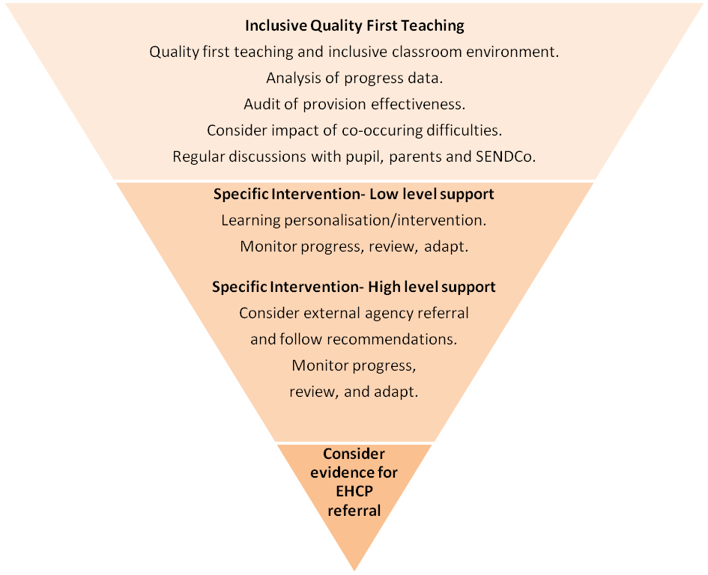

- Schools should provide appropriate resources, programmes and interventions, including those recommended in the Stockport SEN Guidance document, (found in Stockport’s Local Offer website: go to ‘Education & Learning’, then ‘SEN Guidance for Education’) and follow an assess, plan, do, review approach. If the child or young person is on SEND support, this will be part of their SEND Support Plan.

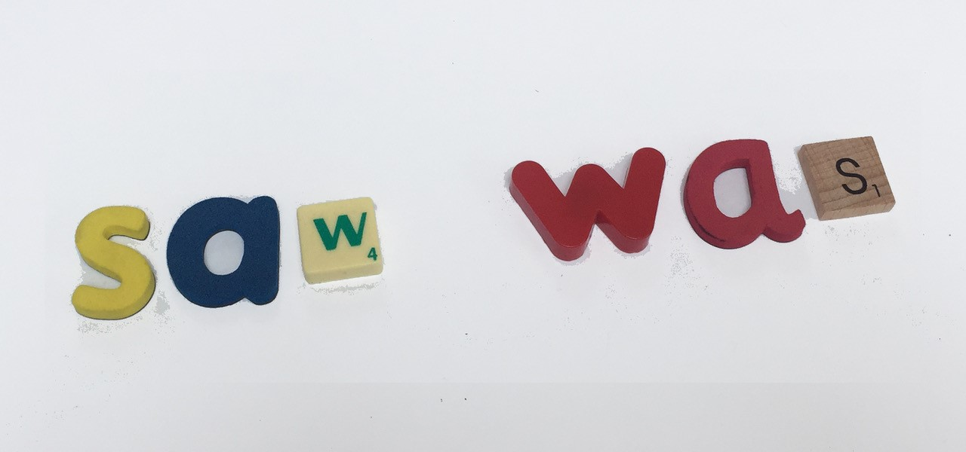
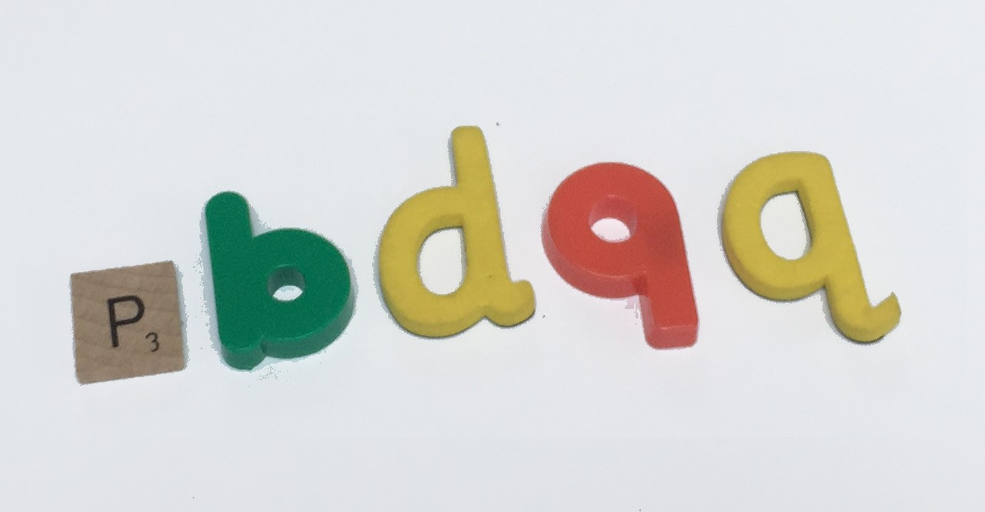

- Many children/young people with dyslexia experience feelings of low self-esteem and high levels of frustration and it is important that emotional support is available from knowledgeable and sensitive staff who understand the impact that dyslexia can have on learning.

- They may seek advice or support from the Inclusion Service.

- The school can provide Interventions such as Stockport Early Reading Intervention, Toe by Toe, and Write Away Together.

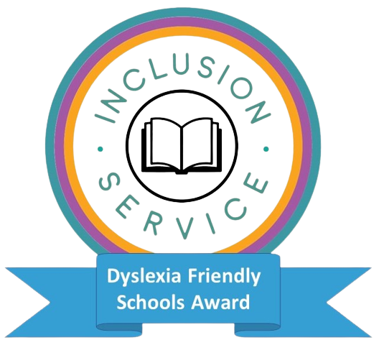
- Schools can also promote dyslexia friendly classrooms and/or achieve Stockport’s Dyslexia Friendly School’s Award, adapting the environment to enable inclusive learning.

- The whole school should adopt an ethos that takes account of individuals’ differences.

Early Identification and Assessment
Identification
There is clear and consistent evidence that early identification of learning difficulties is key to providing effective interventions and preventing difficulties from becoming worse.
Assessment
There is no single test which will indicate dyslexia; rather there are a range of materials that can be used effectively by schools to help them assess ongoing literacy development and address areas of difficulty.
One recognised model of identification and assessment that schools should use is to consider a child’s/young person’s response to intervention, such as an increase in reading age or improvement in spelling after completing ‘Stockport Early Reading Intervention’ and supporting strategies.
Screening
A number of assessment tools are available to schools that give an indication of whether a child/young person is at risk of dyslexia. These can be effectively used by teachers to identify children and young people who are failing to respond to high quality teaching and who may need additional support.
When used effectively they can highlight areas of strength and difficulties, and help schools to determine the most effective intervention programmes and/or resources and strategies.

The Role of SEND Services
Teachers from the Inclusion Service can support schools in training and advising on support for individual pupils. They can work with the school staff to achieve a better understanding of the factors that may be affecting progress, and support schools to identify ways forward. Specialist Services can also support schools to develop interventions and advise on suitable resources.
In some cases, assessments tools are also used. The focus for these assessments is identification of need and consideration of the best way to respond in order to provide effective support for learning progress.
Sometimes parents seek an assessment and ‘diagnosis’ by independent specialists. These reports can provide further supporting information, but if the assessor does not have wider access to information about the learning context and progress of your child over time, it would only be a ‘snapshot’ of their experienced difficulties. School staff are in the best position to observe and identify difficulties as they emerge.

Using the term ‘Dyslexia’
Consideration should always be given to whether using the term dyslexia is helpful to your child. Many children/young people and parents find it reassuring to be able to describe their difficulties in this way, whilst others may feel that it limits understanding of the individual’s profile.

How can you support your child or young person?

Engagement and regular communication from and with school with regard to your son/daughter’s progress is central to pupil progress.
Identified difficulties should be discussed at the earliest opportunity with school.
Working collaboratively with school and other services in the best interests of your child/young person, to promote, support and monitor any agreed programmes at home is essential.
This learning collaboration with school and/or other services may include:
- Listening to and, where appropriate, acting on your concerns.

- Providing guidance about how you can help your child at home.

- Helping you to encourage language development through talk.

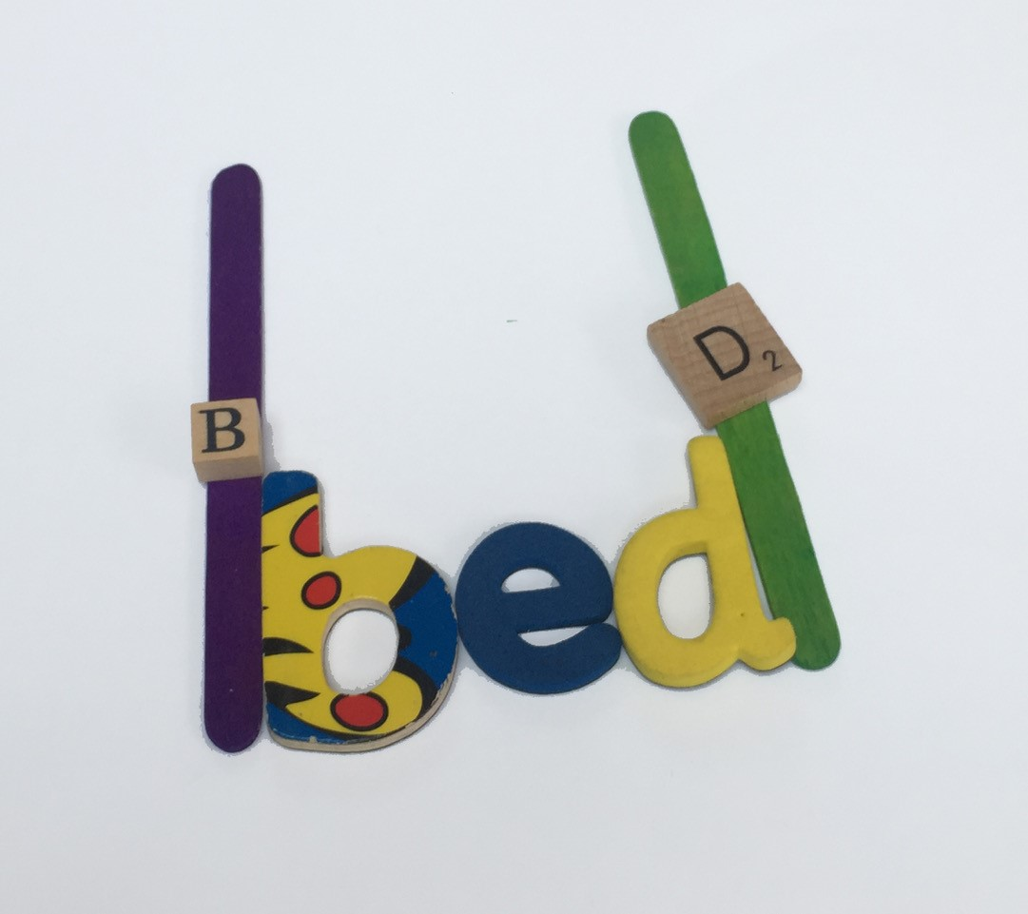
- Promoting the development of organisational /self-help skills

- Providing positive and appropriate feedback to foster and maintain self-esteem as a learner.

How can assistive technology help your child?
Some children and young people with literacy difficulties will benefit from assistive technology. This is an area that is continually growing and improving. These are a few current recommended resources:

- Clicker – a widely used reading and writing tool
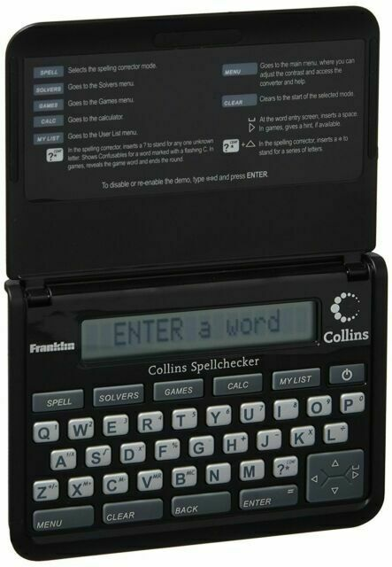
- Dragon dictate/Dragon Naturally Speaking – dictation tool using voice recognition software
- Electronic phonetic spell checker
- Exam pen/Exam reader – Instantly displays on the screen, and says, scanned words or lines of text aloud
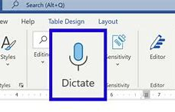
- Whispersync – an App for kindles that allows you to switch between reading and listening
- Co-writer / Sprint-plus – Predictive text software
- Kidspiration – Mind mapping, a cross curricular visual workspace
- Audio books/ebooks
- Text to Speech software (Word has Dictate feature) and ‘Read Aloud’ on webpages or Word
- Use of laptop/chromebook/iPad for writing
- Touch typing programmes such as BBC Dancemat

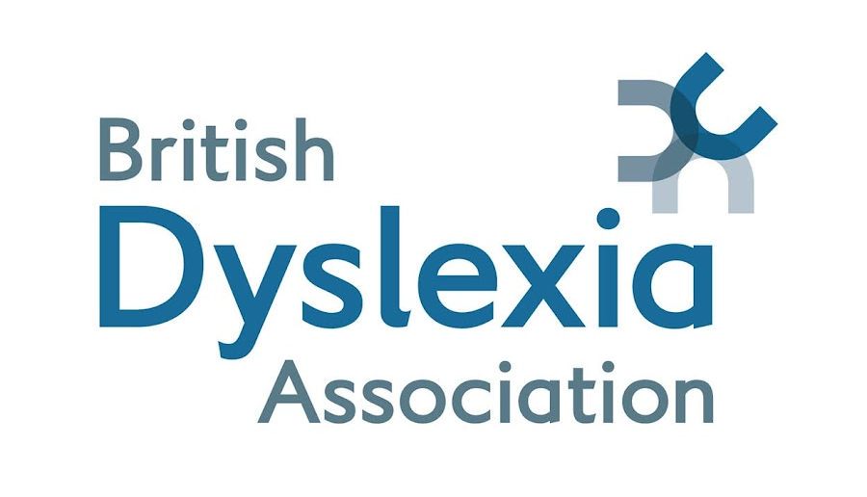

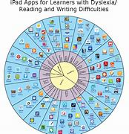
Useful Websites

www.bdadyslexia.org.uk/parent

www.nessy.com/uk/parents/dyslexia-information

http://www.callscotland.org.uk
Useful App wheel downloads for iPads/Chromebooks /android devices

Stockport Services

Inclusion Service Is.admin@stockport.gov.uk Phone: 474 4470

Parents & Carers Together Stockport info@pactstockport.co.uk 

